Month:
 |  |  | 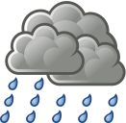 | 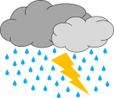

Month:
Day: | Temperature:
1
2
3
4
5
6
7
8
9
10
11
12
13
14
15
16
17
18
19
20
21
22
23
24
25
26
27
28
29
30
31
Average Temperature:
Weather Analysis

Look at your data. Decide what type of weather was the most common each month.
September: ________________ October: ________________
November: ________________ December: ________________
January: ________________ February: ________________
March:________________ April: ________________
May: ________________ June: ________________

Record the average temperature for each month.
September: ________________ October: ________________
November: ________________ December: ________________
January: ________________ February: ________________
March:________________ April: ________________
May: ________________ June: ________________

